Lab 1
UR e-series – Teach Pendant Intro and Safety

Author: Ryan Cullen, SFSU MSME 2026
Overview:
In this lab you will meet the UR robot hardware, learn to power it on and off safely, and receive an in-depth introduction to the safety features of UR e-series manipulators and the PolyScope X software running on the Teach Pendant.
Learning Objectives:
- To identify the main system components and safely power the robot on, unlock it, and return it to Home
- To understand how the safety features of UR e-series robots help to protect operators
- To gain hands-on familiarity with Teach Pendant and understand how to configure the robot, set up safety planes and force limits, and use FreeDrive mode
References:
[1] UR e-series User Manual for your robot model (UR3e edition linked; page numbers may shift slightly for other models) – See chapters 1 and 2 for in depth explanations of safety features
[2] Robotiq 2F-85 Gripper Manual – Section 6.2.3 contains relevant TCP information

1 System Components
Familiarize yourself with the components shown in Fig. 1. The system consists of:
  - UR Robot Manipulator (e.g., UR3e)
  - Gripper / End effector
  - Control Box
  - Control Box Key
  - Teach Pendant
  - Suction Cups
  - E-Stop (Emergency Stop)
  - Power Button
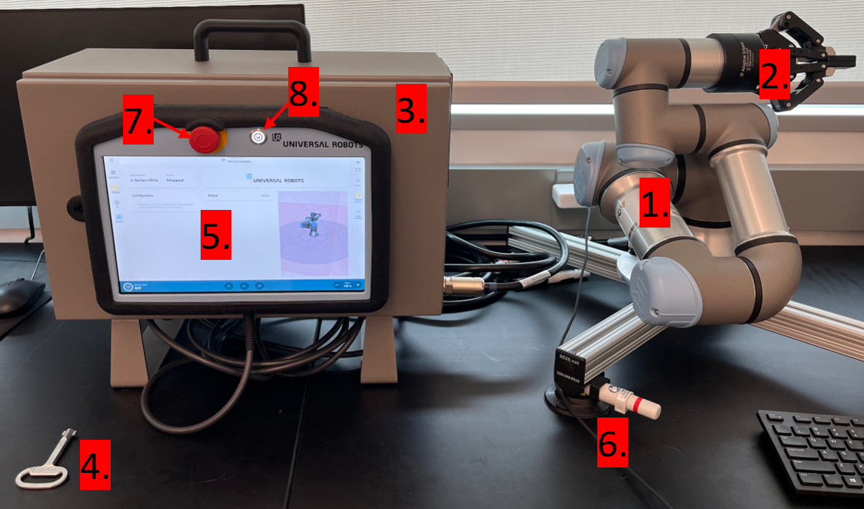
Figure 1 - UR Robot Manipulator + Control Box setup.
Also familiarize yourself with the joint labels shown in Fig. 2. The UR e-series robots have six joints labeled Base, Shoulder, Elbow, Wrist 1, Wrist 2, and Wrist 3.
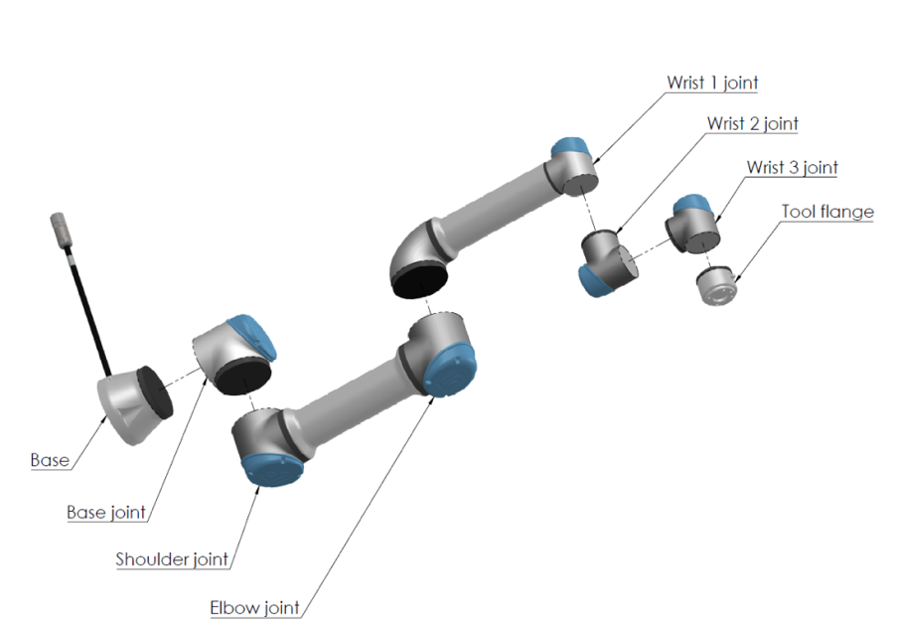
Figure 2 – UR e-series Robot Joints and Labels.

2 Powering the Robot On and Off
Before powering on, every time: keep the workspace clear, know where the e-stop is, and set the speed slider (bottom right of the pendant screen) to 25% or lower. If you are using a benchtop robot, press the pistons on the sides of the suction cups until a seal is made so the base cannot tip.
Power up: on the Teach Pendant screen: (1) press the Power button in the bottom left corner, (2) press Power On, (3) press Unlock to enter the Active state. This releases the motor locks. THE ARM IS NOW ACTIVE AND READY TO MOVE.
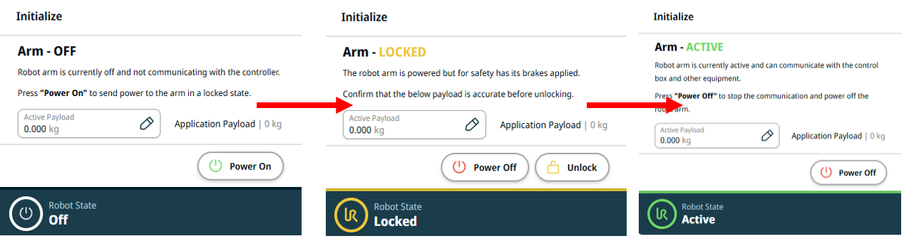
Figure 3 - Power up and unlock sequence on the Teach Pendant.
Homing: always return the arm to the Home position before and after a session, and before sending new commands. Navigate to the right sidebar and tap Move → Smart Skills → Home, as shown in Fig. 4.
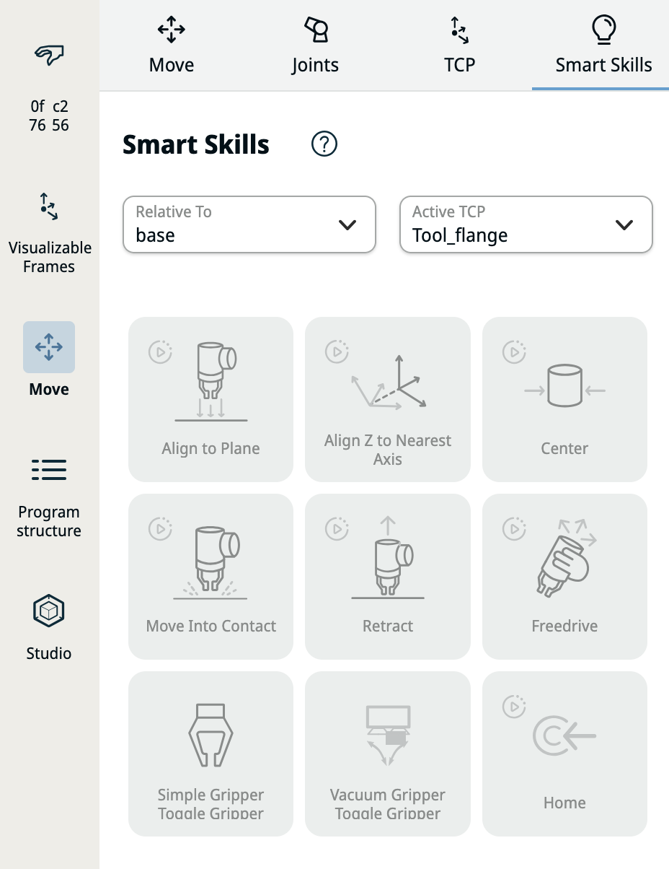
Figure 4 - The Smart Skills screen. The Home button is in the bottom right.
Power down: move the robot back to Home (Move → Smart Skills → Home), then press the power button on the Teach Pendant.

3 Safety Settings and Features

3.1 Emergency Stop (E-stop) ([1], pg.10)
Purpose: To immediately halt unexpected or unsafe behaviors of the robot
- A red button found on the teach pendant
- Try This:
  - Press to cut power to the motors; this immediately stops all robot motion
  - Twist clockwise to release. The robot stays disabled until you press Power On, then Unlock, on the pendant (see Section 2)

3.2 Payload Settings ([1], pg.99)
Purpose: When installing a new end-effector (gripper, dispenser, etc.) or when picking or placing an object, accurate payload info must be given for safe motion and collision detection.
Example: Follow these steps to add the Robotiq 2F-85 Adaptive Gripper:
- Go to Application > End Effectors > Payload on the teach pendant.
- Press + Add End Effector
- Consult the 2F-85 Gripper Manual ([2], 6.2.3) and find the row for 2F-85 (Fig. 5 below)
- Enter the following values from the data sheet into the payload settings:
  - Payload (mass of the end effector): 0.921 kg
  - Center of gravity offset (x, y, z position): (0 mm, 0 mm, 60.0 mm)
- Press + Add TCP to configure the TCP (Tool Center Point)
- Enter the following values (relative to the tool flange):
  - Position (x, y, z): (0 mm, 0 mm, 174 mm)
  - Orientation (x, y, and z rotation): (0°, 0°, 0°)
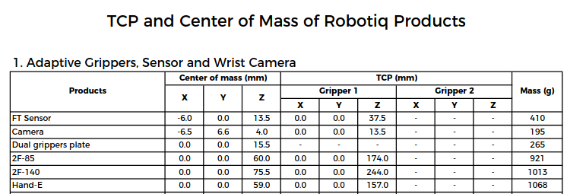
Figure 5 - Data Sheet for Robotiq Grippers/End Effectors (look for 2F-85)

3.3 External Payload Settings:
Caution: Payload parameters (Mass, CG, tool sphere) must be updated whenever the payload changes (e.g., when picking or placing an object) — set it on the pendant (Application > End Effectors > Payload). ([1], p.61)

4 Creating Virtual Safety Planes ([1], pg.23)
Purpose: To create virtual walls that restrict the robot’s working area and protect users or equipment in the vicinity of the robot.
Example: Follow these steps to add a rear wall safety plane that is 200mm away from the robot’s base XYZ frame:
- Go to: Application > Safety > Planes
- Press: + Add Plane
- For each plane, define:
  - Position (offset in mm relative to the base of the robot)
    - Set position to: 200mm
  - Orientation (Tilt/Rotation in degrees)
    - Set Tilt to: 90° (this will make a vertical plane)
    - Set Rotation to: 0° (this faces the plane normal to the -Y direction)
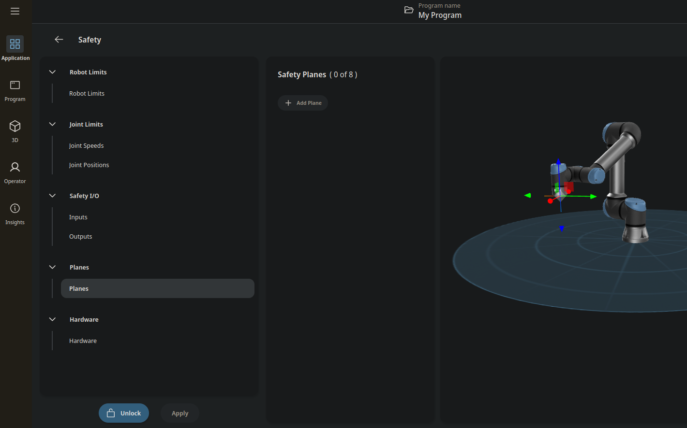

Figure 6 - Safety Plane configuration screen. You can add up to 8 safety planes.

5 Robot Limits ([1], p.19)
Purpose: Used to limit the speed and force of the robot’s joints and end-effector. You can modify each joint's speed limit individually. Only the TCP and elbow joint have modifiable force limits.
Example: Follow these steps to adjust the speed and force limits
- Application > Safety > Robot Limits
- Record the limits currently configured on your robot and compare against the values below:
  - Power (net mechanical power the arm can transfer on impact): 300W (PolyScope default; values may have been adjusted for your installation)
  - Momentum (net momentum of the robot): 25 kg·m/s
  - Stopping Time (max time between stop request and execution): 0.4s
Stopping Distance (max distance between stop request and execution): 0.5m
  - Tool speed (Speed of the TCP): 1.5 m/s
  - Tool Force (Contact force applied at the TCP): 150 N
  - Elbow Speed (Speed of the elbow joint): 1.5 m/s
  - Elbow Force (Contact force applied at the Elbow Joint): 150 N
- Application > Safety > Joint Speeds
- Record the limits currently configured on your robot and compare against the values below:
  - Base, Shoulder, Elbow: at or below the datasheet maximum for your model (UR3e/UR5e: 180°/s; UR10e/UR16e: 120°/s for Base and Shoulder, 180°/s for Elbow)
  - Wrist 1, Wrist 2, Wrist 3: at or below the datasheet maximum for your model (UR3e: 360°/s; UR5e/UR10e/UR16e: 180°/s)
- Application > Safety > Joint Positions
  - Adjust these to restrict the movement of a particular joint
  - Generally not needed for simple setups with well-defined boundaries

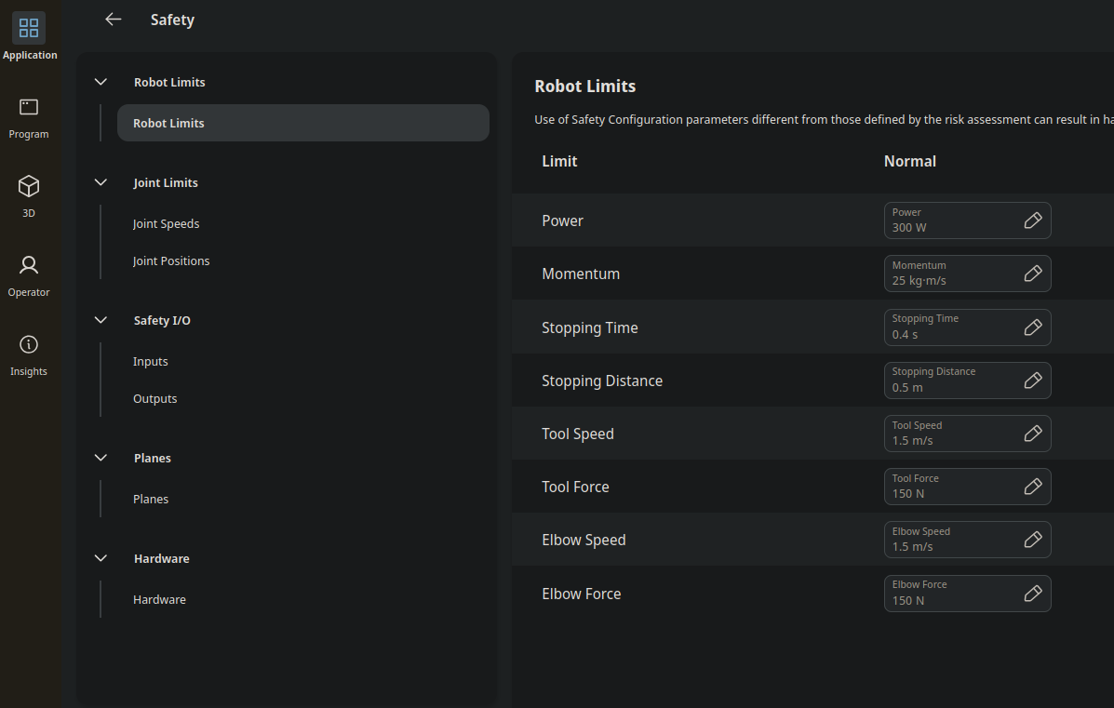

Figure 7 - Robot Limits safety configuration screen

6 Protective Stops
Purpose: Halts the motion of the robot; triggered when the robot detects abnormal forces, hits an obstacle, or exceeds its safety limits.
- Executes an immediate stop, cutting power to all motors.
- The teach pendant will display a warning with a description of the stop cause.
- Possible causes:
- Robot Crossed a Safety Plane
⚠️ Caution: Safety Planes are only respected by the TCP and Elbow Joint
- Exceeded Force Limits
  - Can be set by the user for the following hardware components:
    - TCP
    - Elbow Joint
⚠️ Caution: Force Limits for lower joints cannot be set by the user
- Exceeded Speed Limits
  - Speed limits can be set for every joint (°/s)
  - Lower speeds will increase safety
- Exceeded Position Limits
  - Use this to define any workspace boundaries that are not handled by your Safety Planes, or to restrict the movement of a particular joint
- After clearing the cause (acknowledge the stop on the pendant and press Play to resume.)
- Note: these stops are respected by the robot even when controlling the robot externally via MATLAB or ROS2
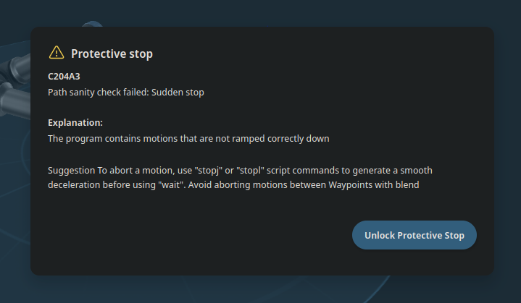
Figure 8 - Protective Stop example; Make sure to review the explanation before unlocking

7 FreeDrive Mode
Purpose: FreeDrive lets you teach positions by physically guiding the arm instead of jogging it joint by joint. You will use it in Lab 4 to record waypoints quickly.
Try This:
  - With the robot powered on and unlocked, hold the FreeDrive button on the back of the Teach Pendant (or use the Freedrive control on the Move screen) and gently guide the arm. Release the button and the arm locks in place.
  - Payload settings must be correct (Section 3.2) or the arm will drift or fight you in FreeDrive.
  - Safety limits stay active: guide the arm slowly toward a configured safety plane and feel it stop at the boundary.

8 Safety Checklist
Use this checklist before any session:
- E-stop is tested, accessible, and all users know its location
- Payload settings reflect actual tool in use (mass and CG)
- Safety planes are configured and match physical workspace boundaries
- Protective stops are functional and tested by light contact at low speed
- Speed and force limits are reviewed and set to safe values
- Suction cups are active to keep a benchtop robot from tipping off the workbench
- Robot workspace is clear of any objects not defined by your safety planes or position limits
- Tie up long hair and remove loose fitting clothing

Final Reminders
- Test new code with another party present and at low speed
- Understand why a Protective Stop has occurred; do not simply resume immediately
- Document any changes to the default safety parameters
- Communicate with others when starting autonomous robot function

Assessment Questions
- Q1. Safety planes are respected only by the TCP and the elbow joint. What does this imply about where the wrist or gripper body could still travel, and how would you mitigate that risk?
- Q2. Why must the payload mass and center of gravity be updated when the robot picks up an object, and not only when the gripper is changed? What behavior would you expect if they are wrong?
- Q3. A protective stop occurs partway through a program. Describe the correct sequence of actions before resuming motion.
- Q4. Look up the datasheet maximum joint speeds for the robot model you are using and compare them to the limits configured on your pendant. Which is more restrictive, and why might an instructor lower the limits further for a teaching lab?
- Deliverable: the completed Section 8 safety checklist (initialed by your instructor) and written answers to Q1–Q4.
With safety verified, you are ready to connect the robot to MATLAB in Lab 2!

